

ROBERTS MECHANISM

Submitted by :

DIVITH PHOGAT (CB.EN.U4AIE20013)

JAYANTH M (CB.EN.U4AIE20024)

KARNATI SAI PRASHANTH (CB.EN.U4AIE20027)

Vishnu Reddy

*of*

**2nd SEM B.Tech CSE-AI**

*For the Completion of*

**19AIE113 – MECHANICS**

**CSE – AI**

**AMRITA VISHWA VIDYAPEETHAM, ETTIMADAI**

Submitted on:

**20th July 2021**

# ACKNOWLEDGEMENT

Nammah Shivaya, firstly of all of us express our gratitude to Amma as finally we were able to finish our assignment that has been given by our Mechanics teacher to us.

Next, we would like to express our special thanks to our project guide and teacher Mr.Gopalakrishnan E.A who gave us the golden opportunity to do this wonderful project on the topic “Wiper Mechanism”, which in turn helped us in doing a lot of research in fields we were less familiar with, via which we learned so many new things. We are really thankful to them.

Lastly, we would also like to thank our parents and friends who helped us a lot in finalizing this project within the limited time frame and keeping us motivated throughout the process.

We would like to declare that we never knowingly discredited anyone of their work nor have we made efforts to plagiarize and for those whose work we referred to suitably equip ourselves to complete this project we acknowledge their effort and thank them for it.

**Introduction**

* Many engineering applications require things move in a linear fashion or "straight-line motion". We can use a linear motion guide that can guide a device accurately along a straight line.
* Roberts Mechanism converts a rotational motion to approximate Straightline motion.
* Robert's mechanism can be classified as Grashoff Triple Rocker symmetrical four-bar linkage.



Add a gif offline

* The linkage was developed by Richard Roberts (1789–1864).
* Richard Roberts (22 April 1789 – 11 March 1864) was a Welsh patternmaker and engineer whose development of high-precision machine tools contributed to the birth of production engineering and mass production.

**Objective of Project work:**

* We will be focusing on cutting the shortcomings in this mechanism.
* Most important is that we are not aware of the fact that how efficiently we can use this mechanism like:
  + if at point p1 as we connect a ceiling fan, and increase the speed of this ternary link then we can replace two fans with 1.
  + Robert's mechanism can easily be used for civil and military purposes but there also it is needed to be little cost effective and fast.
  + This mechanism can also be used in plantation (for digging the earth if we attach) plus for harvesting as well.
  + One more thing, whenever we visit the library, we must spend at least an hour to find a specific book. Why not rack of books of specific title or category are placed at point p1 and a button is connected to that point. Whenever user push that button, the whole rack is Infront of him.

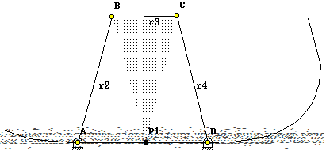

**ROBERT’s Linkage:**

Roberts Linkage is a mechanism of triple rocker kind in which none of the links rotate through 360°.

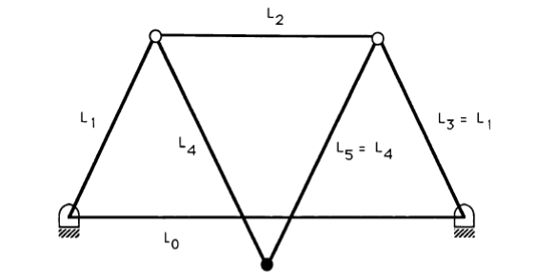

**Smallest Angle:**

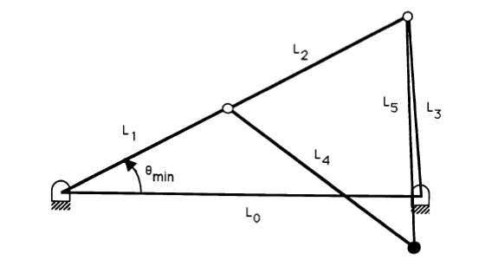

From the limiting positions illustrated above , by cosine law,

**L32 = L02 + (L1 + L2)2 - 2 L0 (L1 + L2) cos θmin**

**=> θmin = cos-1 {[ L02 + (L1 + L2)2 - L32] / 2 L0 (L1 + L2)}**

**θmin = cos^-1{[(2h)^2+(a+h)^2-(a)^2]/2(2h)(a+h)}**

**θmin = cos^-1{[4h^2+(a+h)^2-a^2]/(4h)(a+h)**

**θmin = cos^-1{[4+(2)^2-(1)^2]/4(2)}**

**θmin = cos^-1{[4+4-1]/8}**

**θmin = cos^-1{[⅞]}**

**θmin = 28.95 deg**

**Largest Angle:**

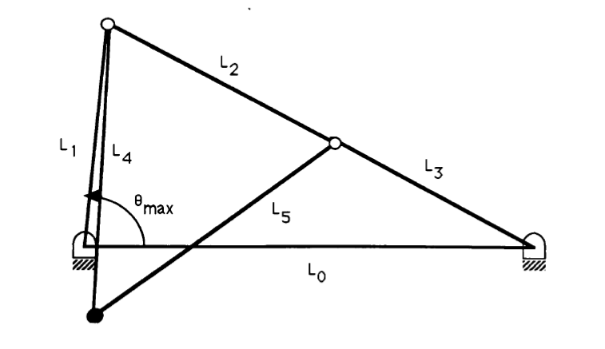

Calculating for the largest angle:

**(L2+ L3)2 = L02+ L12 - 2 L0.L1 cos θmax**

**θmax = cos-1 {[ L02 + L12 - (L2 + L3)2]/ 2 L0.L1 }**

**θmax = cos-1 {[ (2h)^2+(a)^2-(h+a)^2]/2(2h)(a)**

**θmax = cos-1 {[ 4h^2+a^2-(h+a)^2]/2(2h)(a)**

**θmax = cos-1 {[ 4+1-(2)^2]/(2)(2)**

**θmax = cos-1 {[ 4+1-4]/4}**

**θmax = cos-1 {[¼]}**

**θmax = 75 deg 52 rad**

**Position of the Moving Point:**

The vector representation of a symmetrical Roberts Linkage is shown In the below figure.

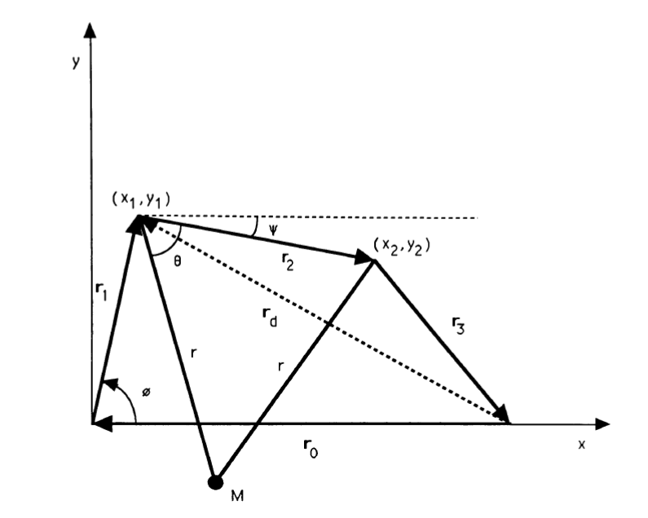

The coordinates (x1,y1) and (x2,y2) are calculated as follows,

**X1 = r1 cos Φ**

**Y1 = r1 sin Φ**

**X2= X1+r2X**

**Y2= Y1+r2Y**

To find the coordinates of the point M(x,y), from the above figure, by the cosine law,

**r2= r22 + r2– 2.r.r2 cos θ**

**θ = cos-1 [ r2/ 2r]**

And the Angle

Ψ = sin-1 [(y1 – y2)/r2]

Finally, the coordinates of the output point M are obtained by,

X = x1 + r cos (θ **+** Ψ)

Y = Y1 – r sin (θ **+** Ψ)

These coordinates of the coupler point can be found for small intervals of 0 between θmin and θmax.

**Robert’s Mechanism in GeoGebra:**

GeoGebra is dynamic mathematics software for all levels of education that brings together geometry, algebra, spreadsheets, graphing, statistics, and calculus in one easy-to-use package. GeoGebra is a rapidly expanding community of millions of users located in about every country. GeoGebra has become the leading provider of dynamic mathematics software, supporting science, technology, engineering, and mathematics (STEM) education and innovations in teaching, and learning worldwide.

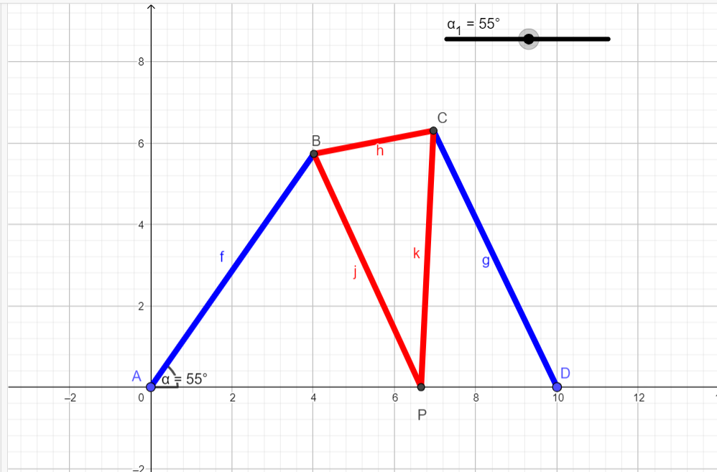

We have Done the Animation of the Roberts Mechanism in GeoGebra:

Lengths:

AB = CD= 7 units

BP = CP = 6.32units

BC = 3 units

AD = 10 units

Maximum Angle = 69.5 deg

Minimum Angle = 40 deg

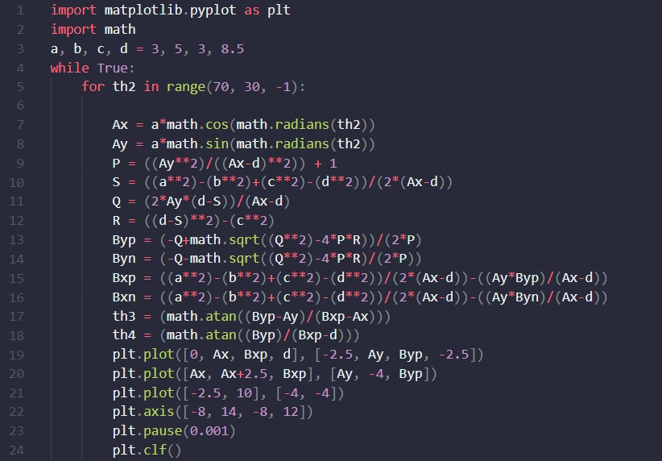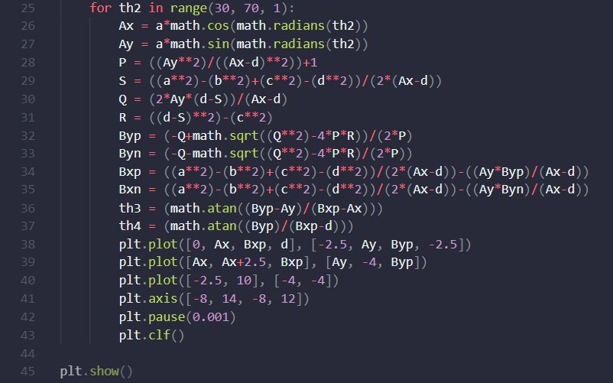**Robert’s Mechanism Animation in Python:**

**Working Screenshots:**

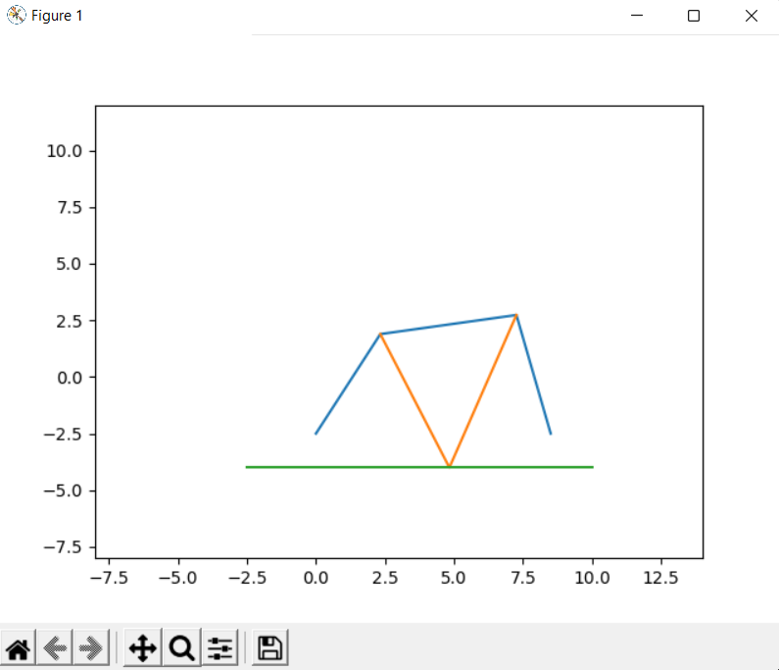

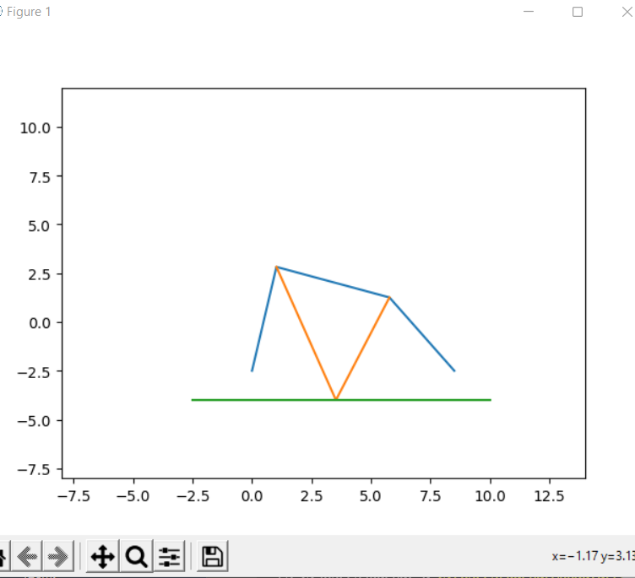

**Robert’s Mechanism Matlab Code:**

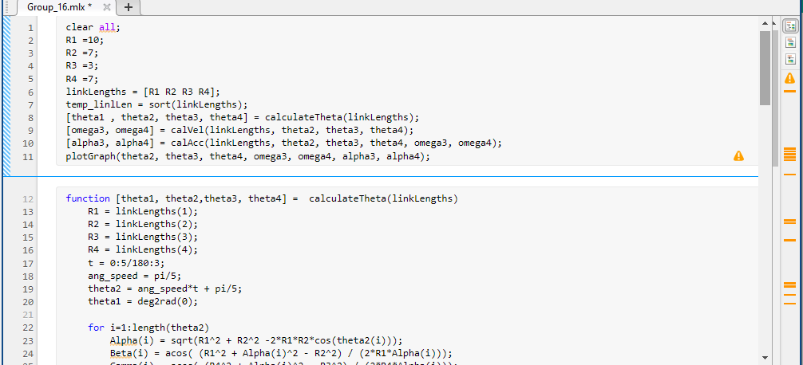

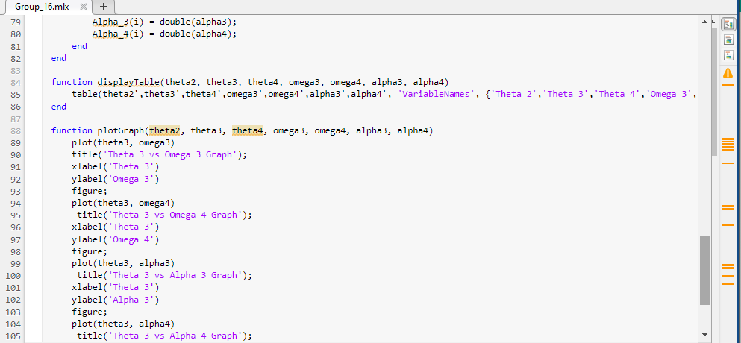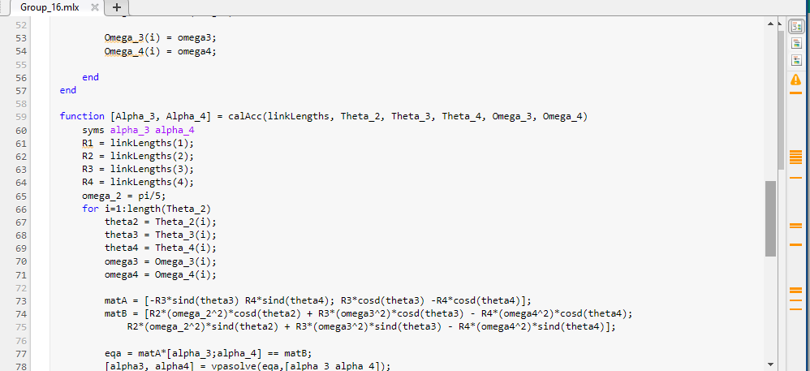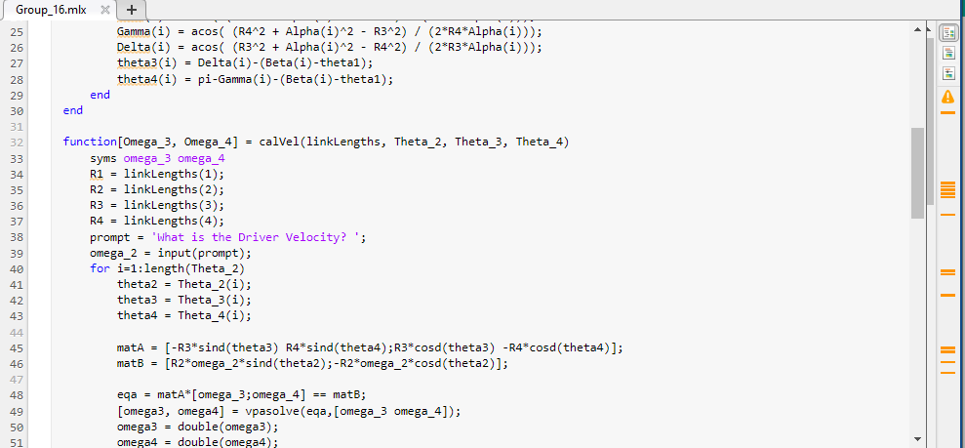

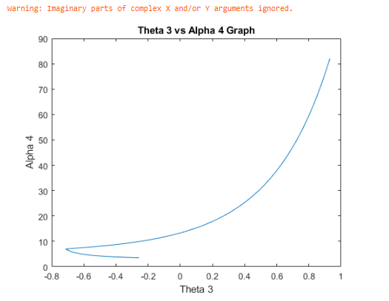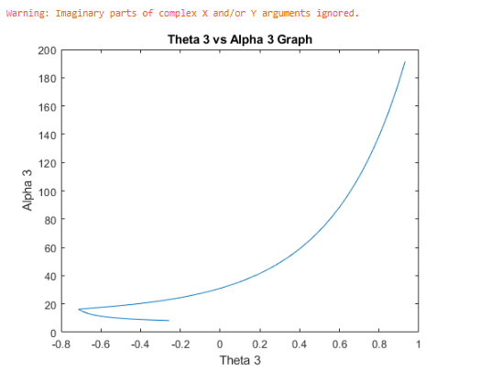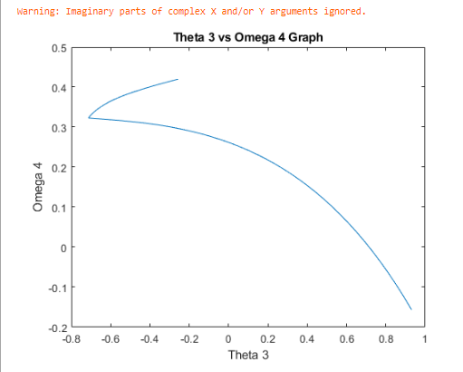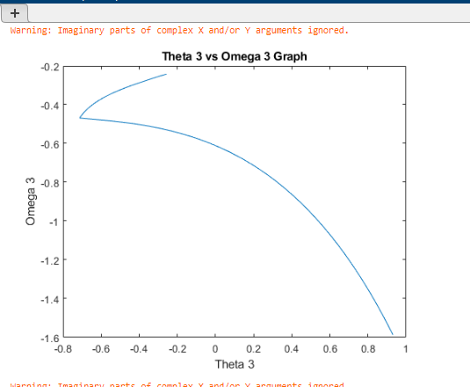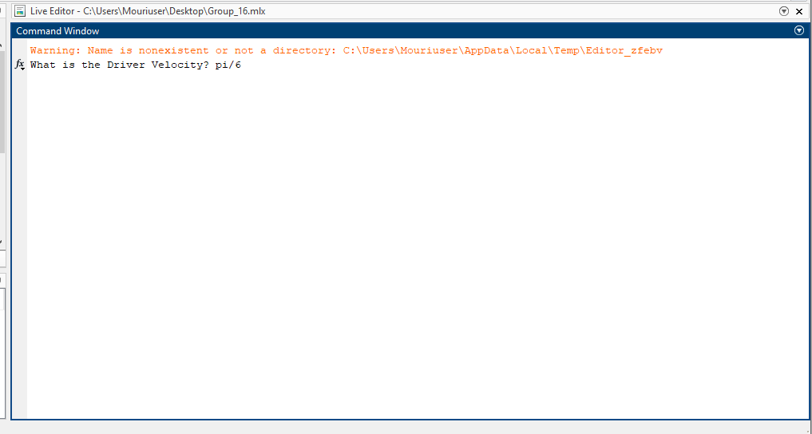**Output of Matlab Code:**